**Map:**

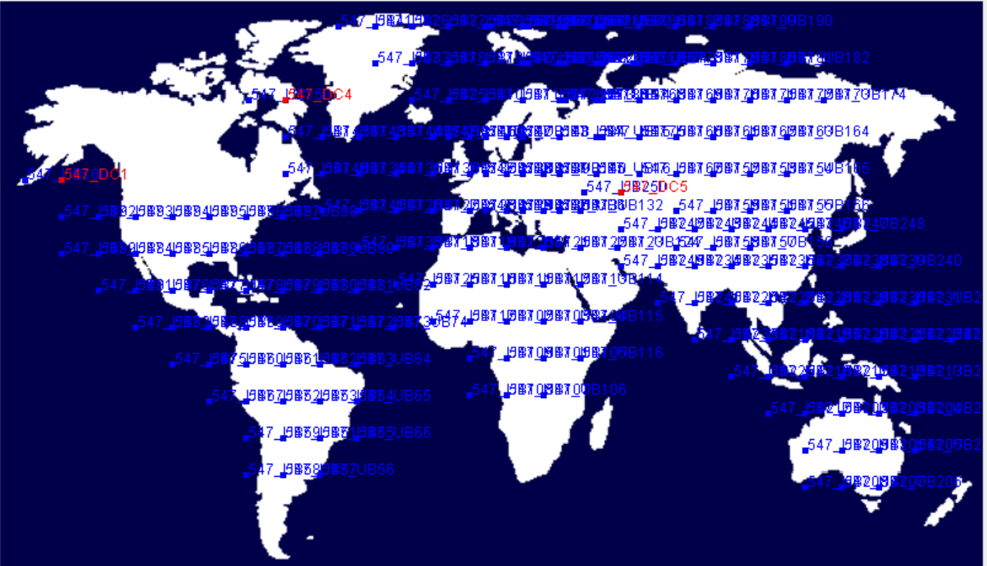

Main Configuration:

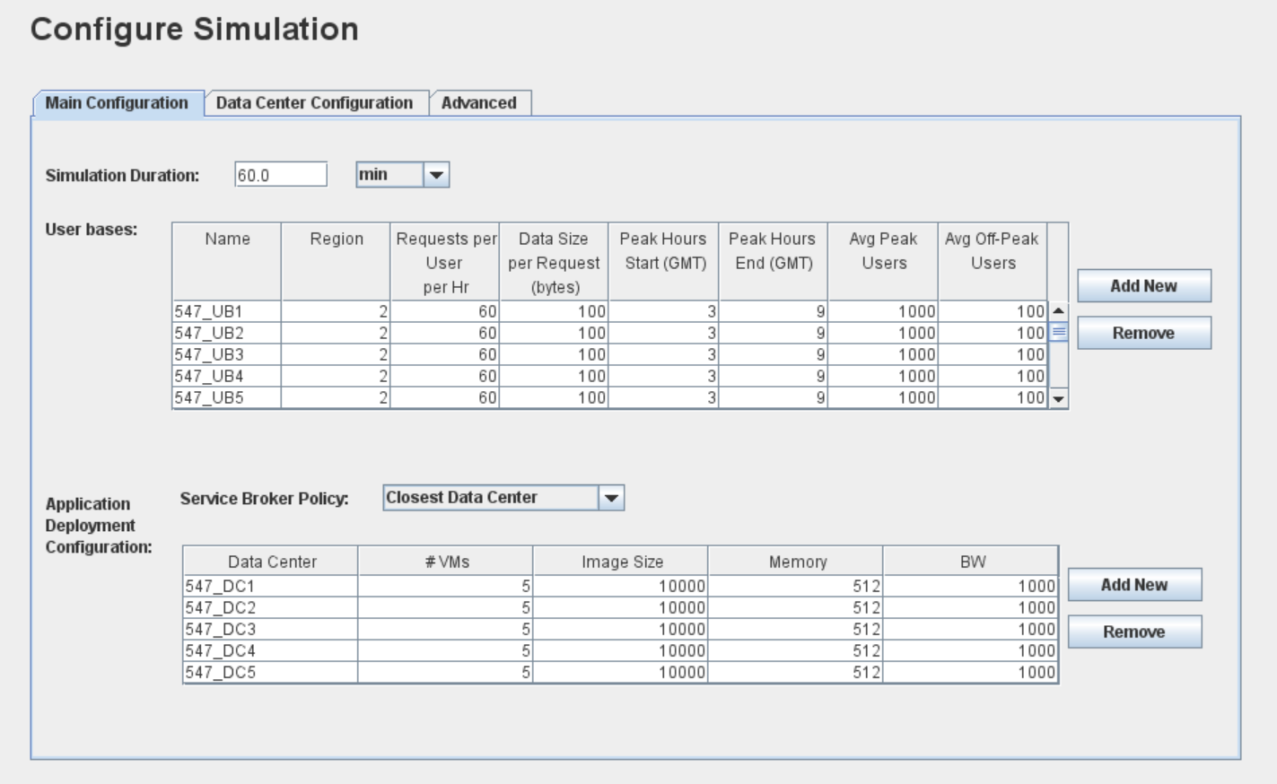

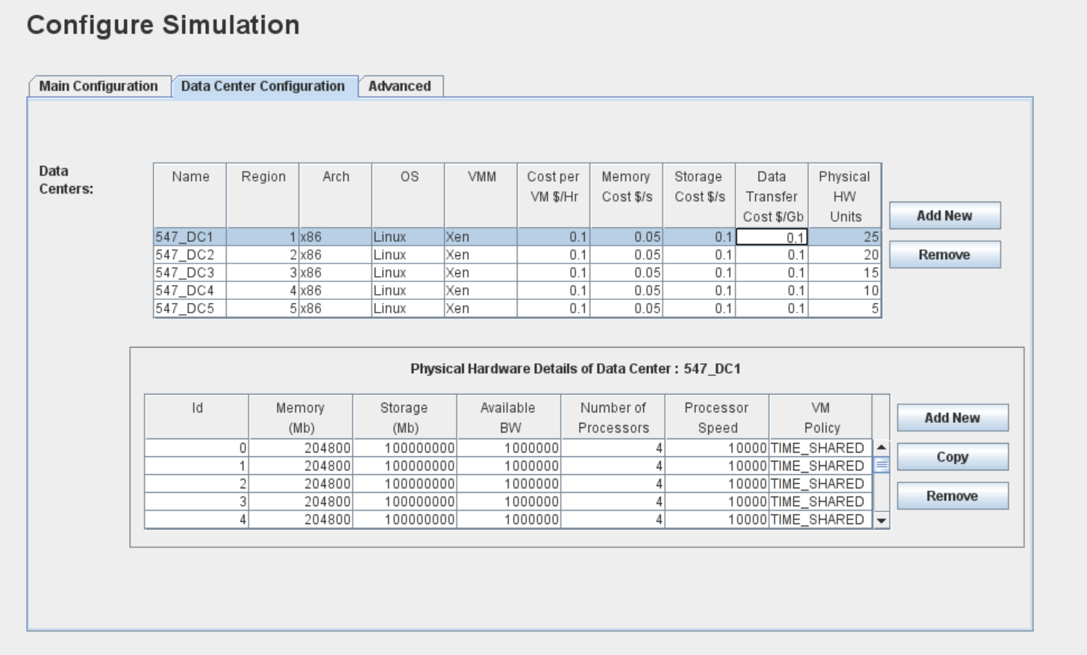

Comparison based on Overall Response Time Summary :

|  |  |  |  |
| --- | --- | --- | --- |
|  | Round Robin | Equally Spread Execution load | Throttled |
| Average | 51.11 | 51.10 | 51.08 |
| Max | 70.00 | 68.89 | 67.24 |
| Min | 36.87 | 36.30 | 36.87 |

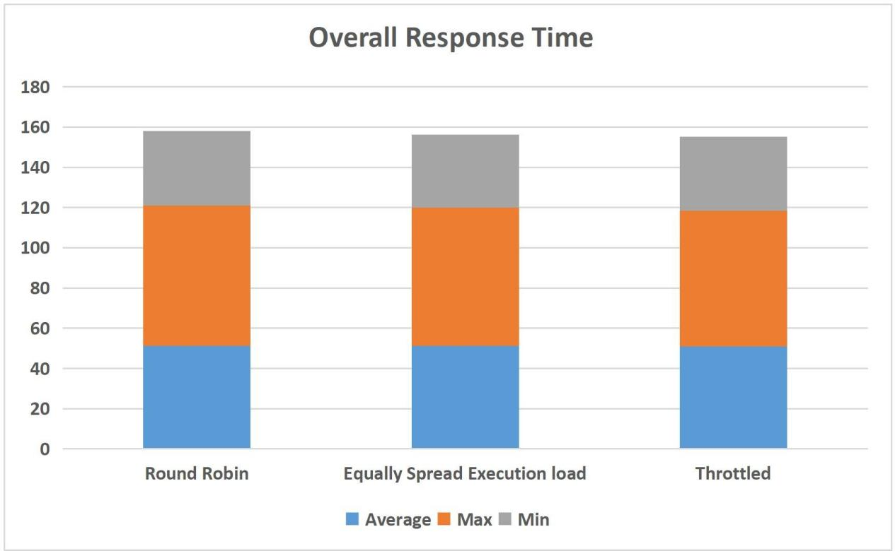

|  |  |  |  |
| --- | --- | --- | --- |
| **Data Center** | **Avg (ms)(Round Robin)** | **Avg (ms)(Equally Spread Execution Load)** | **Avg (ms) (Throttled)** |
| **547_DC1** | 1.49 | 1.47 | 1.45 |
| **547_DC2** | 1.49 | 1.49 | 1.46 |
| **547_DC3** | 1.49 | 1.49 | 1.47 |
| **547_DC4** | 1.50 | 1.50 | 1.47 |
| **547_DC5** | 1.47 | 1.46 | 1.44 |

Comparison based on Maximum Data center request servicing time:

|  |  |  |  |
| --- | --- | --- | --- |
| **Data Center** | **Max (ms)(Round**  **Robin)** | **Max (ms)(Equally Spread**  **Execution Load)** | **Max (ms)**  **(Throttled)** |
| **547_DC1** | 13.41 | 9.27 | 7.36 |
| **547_DC2** | 15.53 | 12.59 | 8.81 |
| **547_DC3** | 13.01 | 11.88 | 9.62 |
| **547_DC4** | 13.81 | 11.64 | 7.72 |
| **547_DC5** | 13.77 | 11.27 | 7.58 |

Comparison based on Minimum Data center request servicing time:

|  |  |  |  |
| --- | --- | --- | --- |
| **Data Center** | **Min (ms)(Round**  **Robin)** | **Min (ms)(Equally Spread**  **Execution Load)** | **Min (ms)**  **(Throttled)** |
| **547_DC1** | 0.02 | 0.02 | 0.02 |
| **547_DC2** | 0.01 | 0.02 | 0.02 |
| **547_DC3** | 0.02 | 0.02 | 0.02 |
| **547_DC4** | 0.03 | 0.03 | 0.03 |
| **547_DC5** | 0.02 | 0.02 | 0.02 |

**Comparison based on Grand Total Cost(total virtual machine cost + total tansfer cost):**

|  |  |  |  |
| --- | --- | --- | --- |
| **Data Center** | **Round Robin** | **Equally Spread Execution Load** | **Throttled** |
| **547_DC1** | 3.44 | 3.44 | 3.44 |
| **547_DC2** | 3.42 | 3.42 | 3.42 |
| **547_DC3** | 3.43 | 3.43 | 3.43 |
| **547_DC4** | 3.44 | 3.44 | 3.44 |
| **547_DC5** | 3.44 | 3.44 | 3.44 |

Overall Response Time Summary:

|  |  |  |  |  |  |  |  |  |  |
| --- | --- | --- | --- | --- | --- | --- | --- | --- | --- |
|  | **Round Robin** | | | **Equally Spread**  **Execution** | | | **Throttled** | | |
|  | Avg(  ms) | Min(m  s) | Max(ms) | Avg(ms) | Min(ms) | Max(ms) | Avg(ms) | Min(ms) | Max(ms) |
| **Overall response**  **time:** | 51.08 | 36.87 | 67.24 | 51.10 | 36.30 | 68.89 | 51.08 | 36.87 | 67.24 |
| **Data Center**  **processing time:** | 1.46 | 0.02 | 9.62 | 1.48 | 0.02 | 12.59 | 1.46 | 0.02 | 9.62 |